
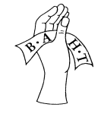
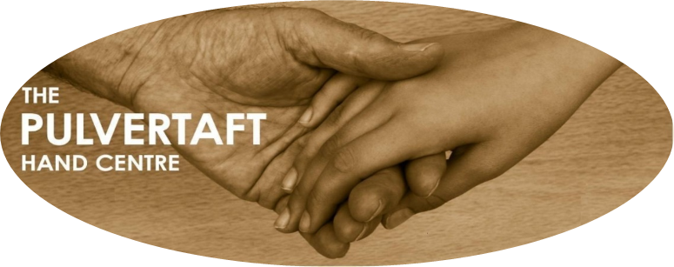
Pulvertaft Hand Centre
Royal Derby Hospital
Uttoxeter Road
Derby, DE22 3NE

Radiographic Imaging of the Hand
British Association of Hand Therapists (BAHT) Level II
(Accredited with 2 BAHT points on course attendance and successful completion of the assessment process)

Dates: 13th – 15th January 2021

3 day ONLINE COURSE
Essential: delegates will need access to a suitable device (e.g. laptop or desktop computer) for the full 3 days of the course and a good internet connection, either at work or at home.

PLEASE COMPLETE CLEARLY IN BLOCK CAPITALS
(NB: The name on the application form is the name that will appear on your certificate)
Surname: | First Name:
Job title:  OCCUPATIONAL THERAPIST/PHYSIOTHERAPIST/RADIOGRAPHER/RGN  (please indicate) |  | Grade:
E-mail address:

Contact details:-Tel (Work): | Tel: (Mobile/Home):
Hospital Name: | Department:
Full hospital address (including post code): | Preferred correspondence address (if different):
Invoicing details (mandatory if funded by employer) | Purchase Order No: (mandatory if funded by employer)
Please note payment is required to formally book a place and must be received prior to the course.
Pre course information including essential reading and preparation resources will only be provided once payment has been received
Please indicate any special educational needs: (written evidence required with application)

COURSE FEE

(PLEASE NOTE: Course fee includes all hand-outs and BAHT assessment)

BAHT Members £400.00 Membership No required: ………………

Non-Members £450.00

We need your permission to ensure that you are happy for us to retain your e-mail address for the next 3 years with the purpose of being able to contact you about our forthcoming courses. Please state when completing this application form whether you wish to be on our mailing list or not, although you do have the right at any time to be removed from it.
Do you wish to remain on our mailing list for future courses (Pulvertaft use only)

□ Yes □ No (Please tick as appropriate)
All the online sessions will be recorded and stored by the Pulvertaft Hand Centre.

Copy Right Notice
The contents of this online course, including (but not limited to) all written material, images, photos are the property of the Pulvertaft Hand Centre and are protected by copyright. You may not copy, reproduce, modify, republish, transmit or distribute (including electronically or by email) any material from this online course without express written permission.
Liability disclaimer
This course teaches you new information and skills. It is important to remember that you are not fully skilled to practice on patients purely by attending this course. Enjoy gaining your skills with each other and have fun!
BAHT is not liable for the delivery, or for the quality of the material issued for this course.

Apply via our website: www.pulvertafthandcentre.org.uk and pay by debit/credit card

Pay by BACS/online banking for further details please contact Linda Tozer (linda.tozer1@nhs.net)

Cheques are also accepted and should be made payable to ‘Pulvertaft Hand Charity’

Completed application forms should be returned to: Linda Tozer, Research & Postgraduate Administrator, Pulvertaft Hand Centre – KTC Level 2, Royal Derby Hospital, Uttoxeter Road, Derby DE22 3NE

Enquiries: Linda Tozer: tel 01332 786964 or via e-mail: linda.tozer1@nhs.net

CANCELLATION POLICY

Please see our cancellation policy on our website www.pulvertafthandcentre.org.uk/cancellationpolicy.Cancellation will incur an administration charge.

